Signal Assignment

**Prepared by**: Qusay Mohammad Bdier

**ID Number**: 1220649

**Instructor**: Dr. Mahran Qaraan

**Section** : 3

**Contents**

Question 1: 3

Code: 3

Plot: 3

Plot: 3

Question 2: 4

Code: 4

Plot: 4

Question 3: 7

Code: 7

Solution: 7

Question 4: 7

**Impulse Response** 8

Simulation: 8

Plot: 8

**Step Response** 8

Simulation: 8

Plot: 9

Question 5: 9

Code: 9

Plot: 9

Question 6: 10

Simulation: 10

Plot: 10

Question 7: 10

Code: 10

Plot: 11

# Question 1:

## Code:

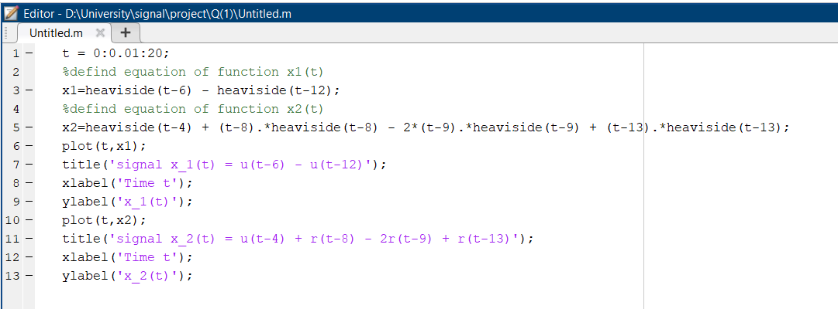

1. x1(t) = u(t −6) − u(t −12)

## Plot:

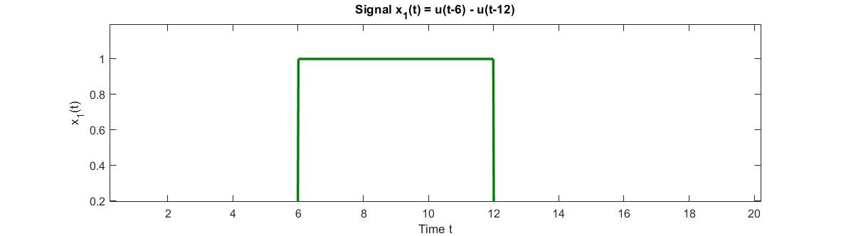

1. x2(t)= u(t −4) + r(t −8) − 2r(t −9) + r(t −13) in the time interval = [0, 20]

## Plot:

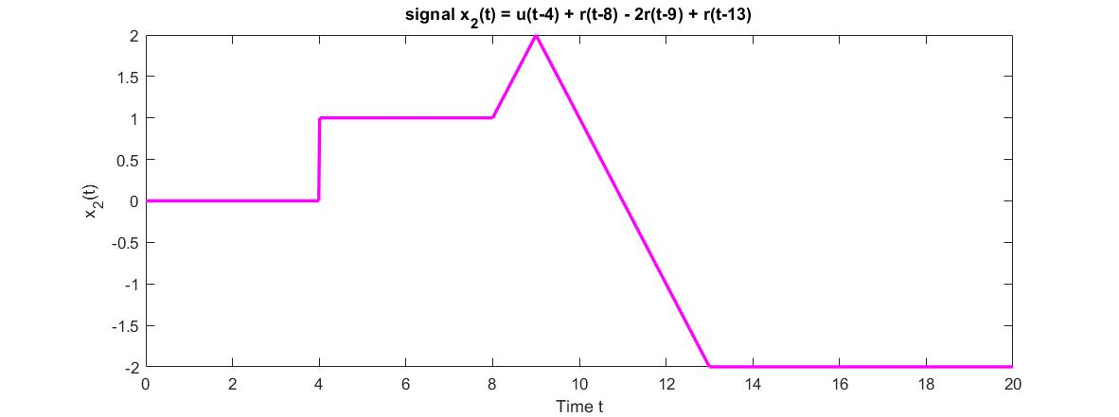

# Question 2:

## Code:

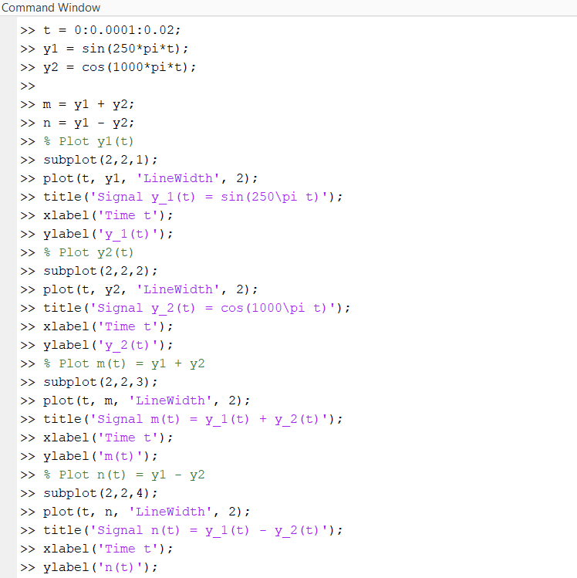

1. y1(t)= sin(250πt)

## Plot:

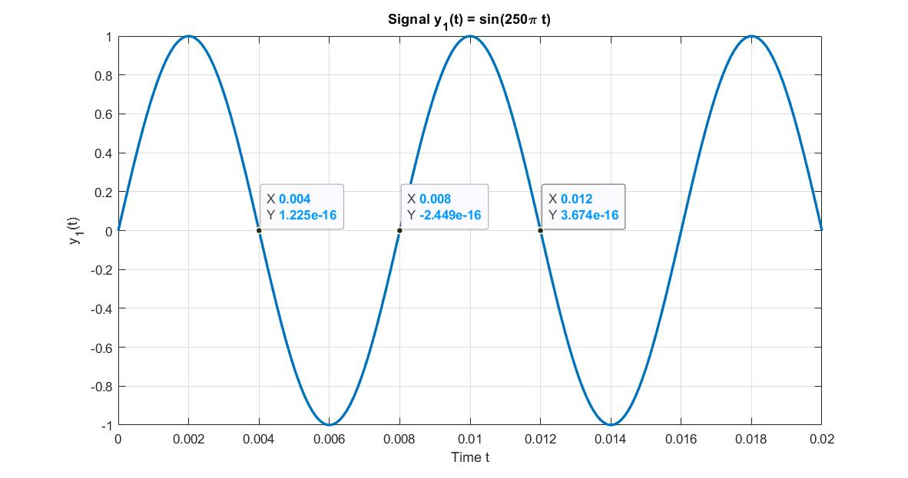

1. y2(t)= cos(1000πt)

## Plot:

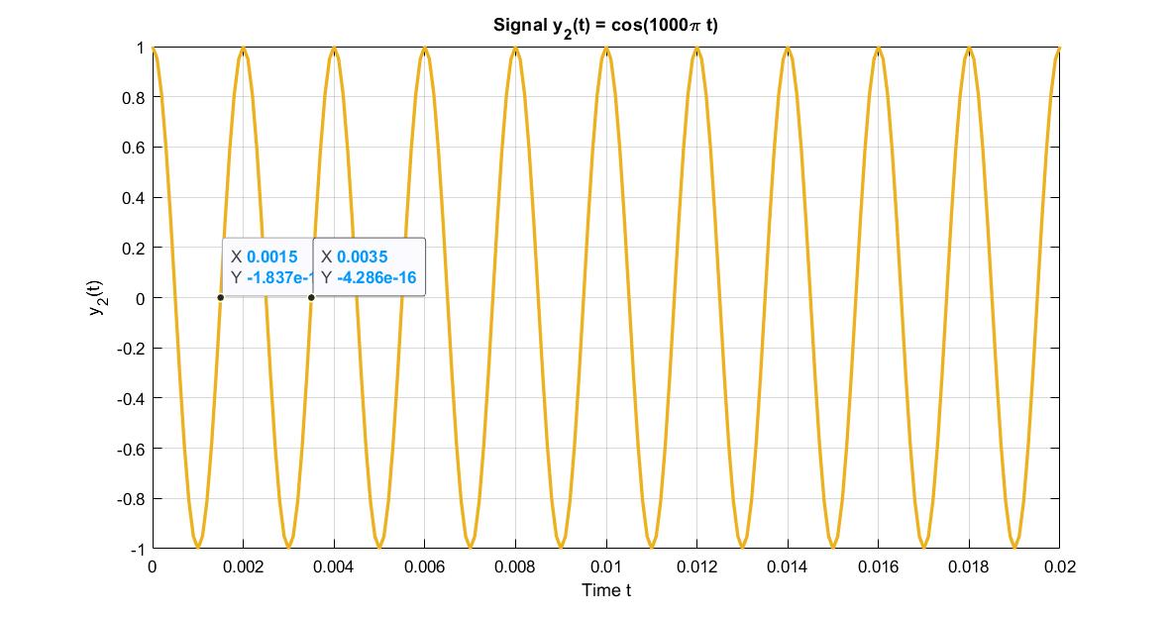

1. m(t)= y1+y2

## Plot:

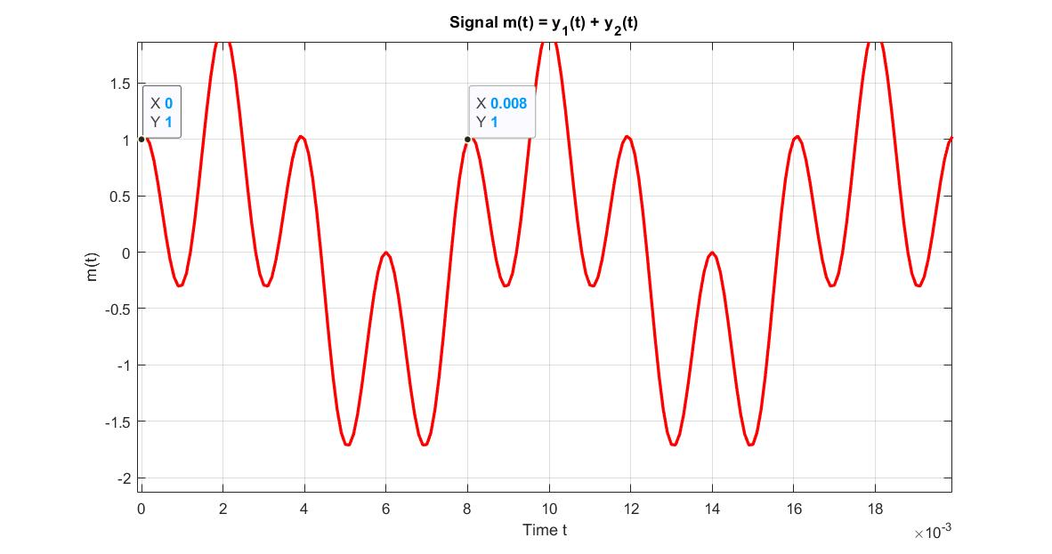

1. n(t)= y1−y2

## Plot:

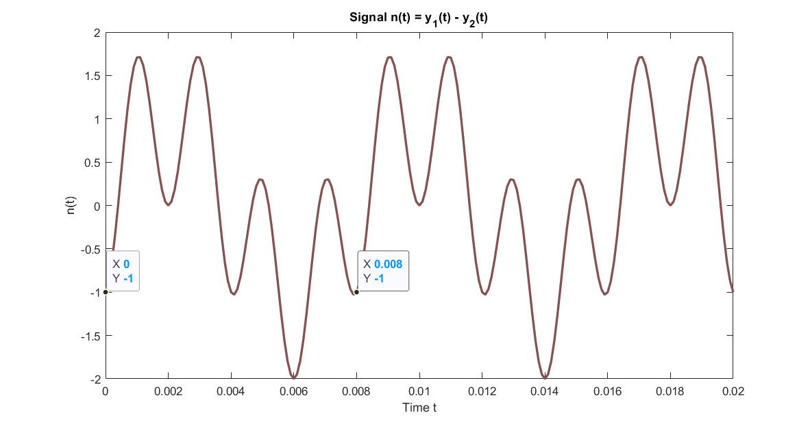

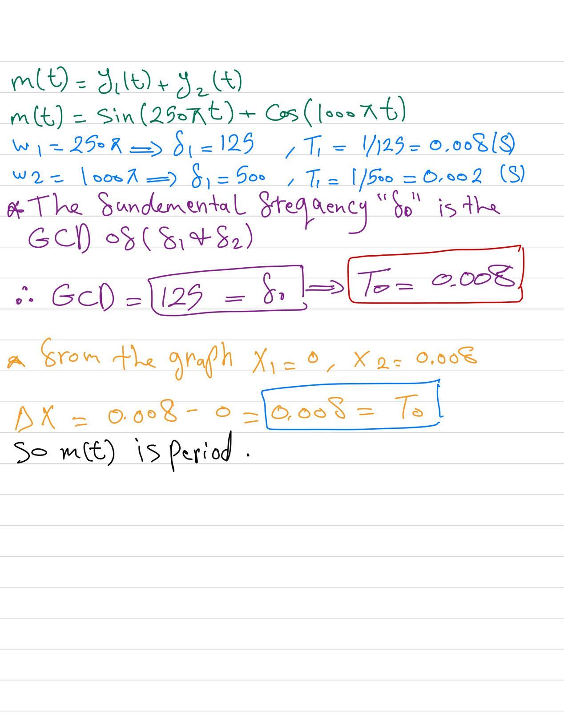

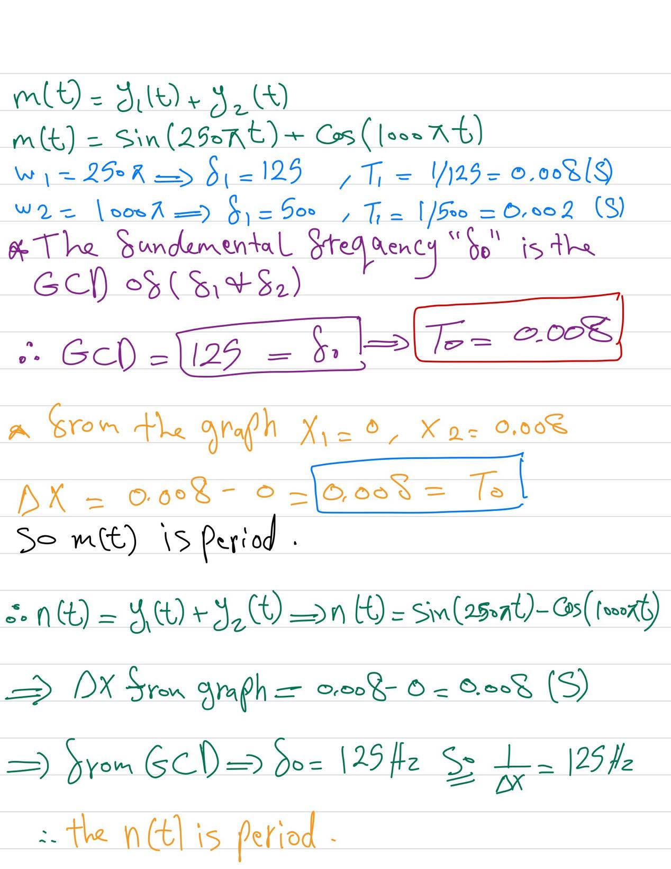

# Question 3:

## Code:

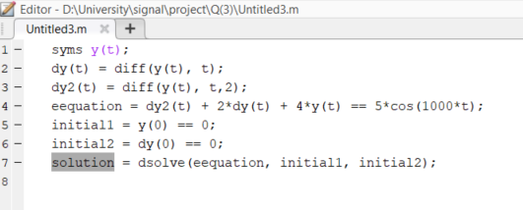

## Solution:

sin(3^(1/2)*t)*((625*cos(1000*t - 3^(1/2)*t))/124999500002 - (625*cos(1000*t + 3^(1/2)*t))/124999500002 - (1249995*sin(1000*t + 3^(1/2)*t))/499998000008 + (1249995*sin(1000*t - 3^(1/2)*t))/499998000008 + (1250005*3^(1/2)*cos(1000*t + 3^(1/2)*t))/1499994000024 + (1250005*3^(1/2)*cos(1000*t - 3^(1/2)*t))/1499994000024 + (312499375*3^(1/2)*sin(1000*t + 3^(1/2)*t))/374998500006 + (312499375*3^(1/2)*sin(1000*t - 3^(1/2)*t))/374998500006) - (5*3^(1/2)*cos(3^(1/2)*t)*((sin(t*(3^(1/2) - 1000)) - cos(t*(3^(1/2) - 1000))*(3^(1/2) - 1000))/((3^(1/2) - 1000)^2 + 1) + (sin(t*(3^(1/2) + 1000)) - cos(t*(3^(1/2) + 1000))*(3^(1/2) + 1000))/((3^(1/2) + 1000)^2 + 1)))/6 - (1250005*3^(1/2)*exp(-t)*sin(3^(1/2)*t))/749997000012 - (1249995*exp(-t)*cos(3^(1/2)*t))/(4*(500*3^(1/2) - 250001)*(500*3^(1/2) + 250001))

# Question 4:

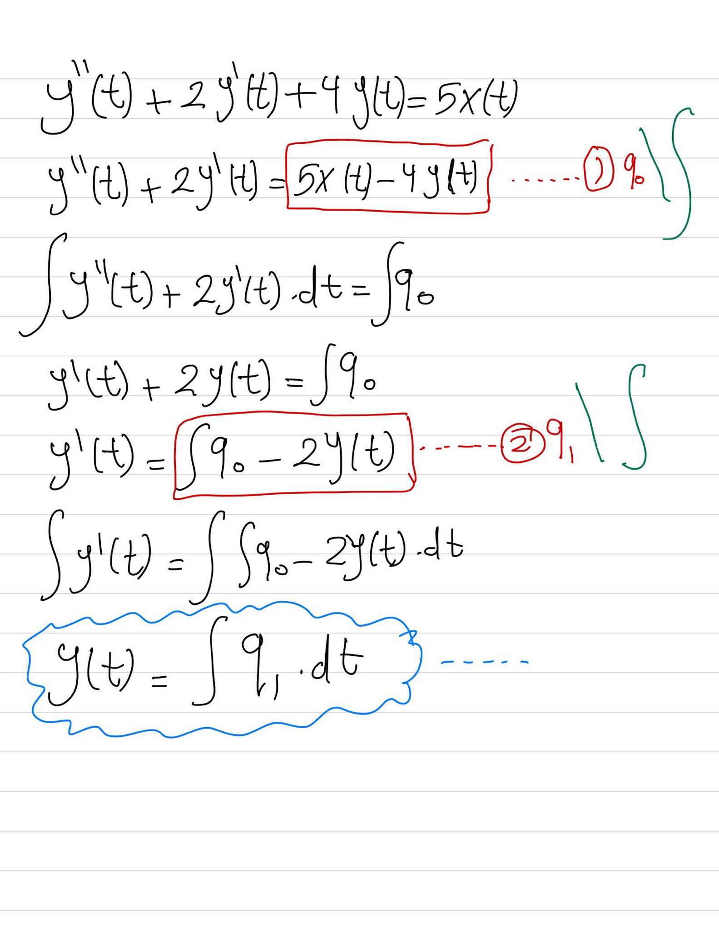

## **Impulse Response**

### Simulation:

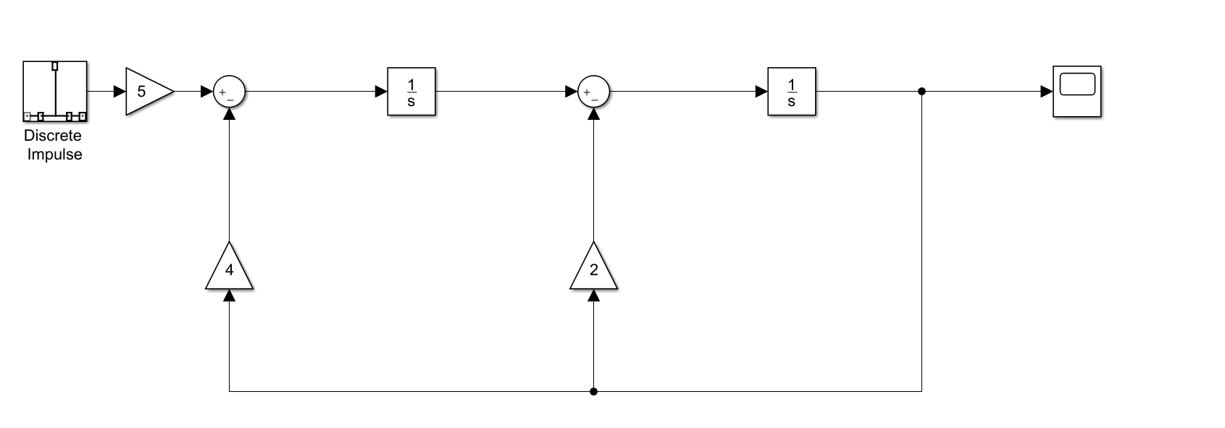

### Plot:

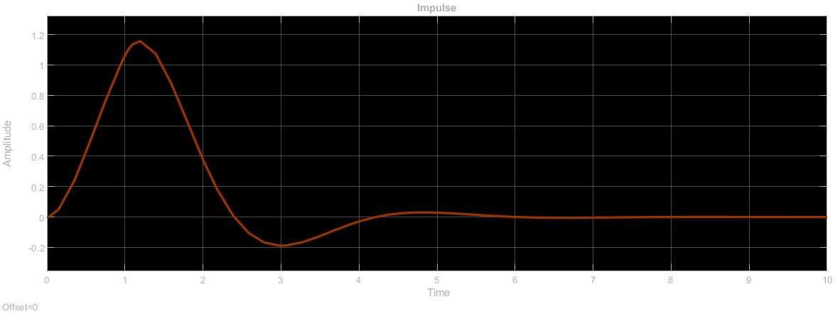

## **Step Response**

### Simulation:

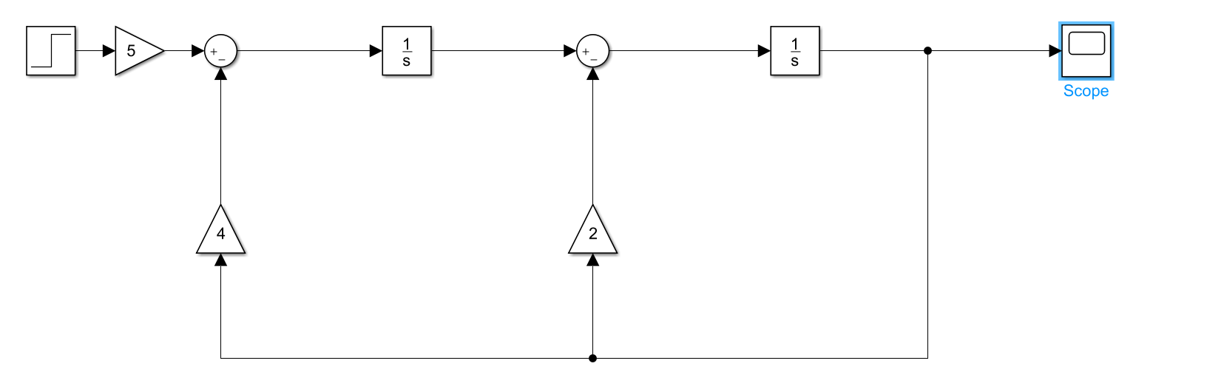

### Plot:

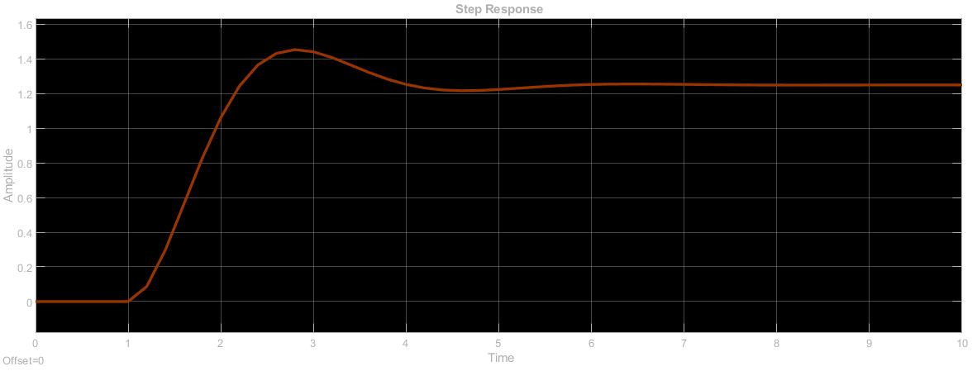

# Question 5:

## Code:

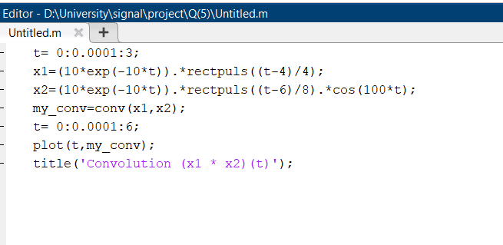

## Plot:

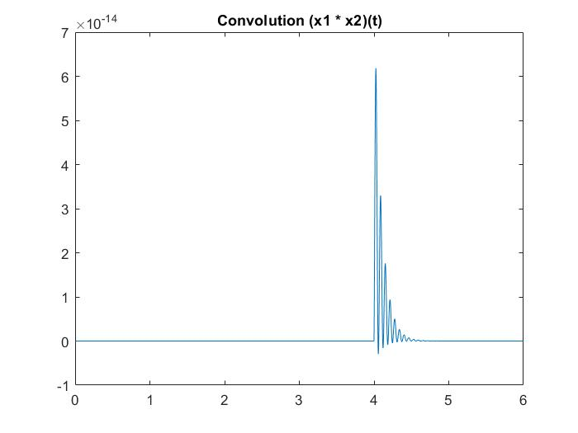

# Question 6:

## Simulation:

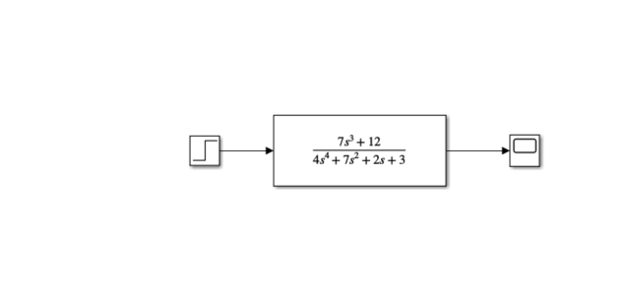

## Plot:

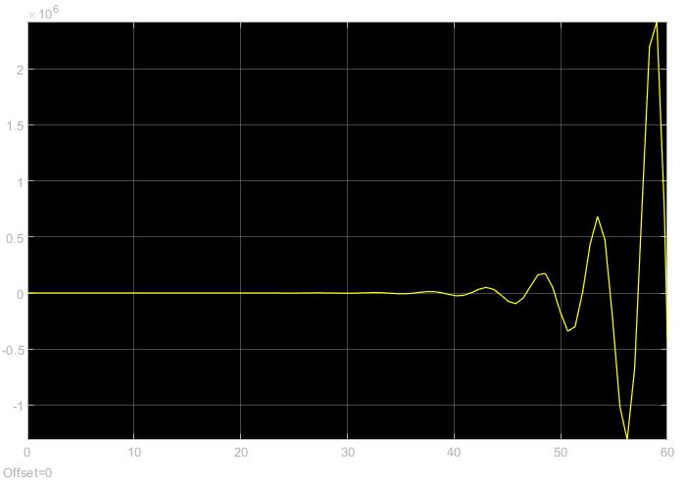

# Question 7:

## Code:

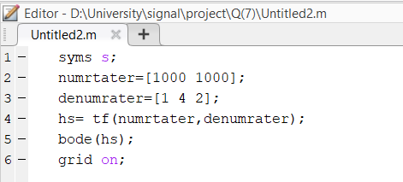

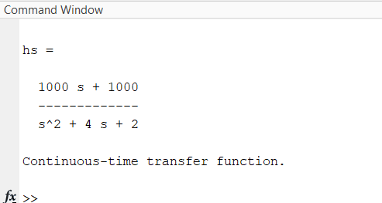

## Plot:

